Professional practice online diary week 3

3.0 Introduction

This week we were tasked to add chance mechanics into noughts and crosses without simply adding in a dice roll that would choose where the players would have to place their noughts or cross. The game would also have to appeal to adults.

3.1 Materials

To play this game all you need

* A piece of paper
* A pen/ pencil

3.2 The game mechanics

We came up with the idea to create 3D noughts and crosses. This idea appealed to us more than keeping the game as 2D because it added more layers to the grid it would make the game much more complex and strategy reliant which is something that would appeal more to adults than children as it makes the game more difficult and challenging which is something that appeals more to adults than children. The game is still winnable in the traditional fashion by simply just using the X and Y axis on the grid to get three in a row however by adding the Z axis it creates more ways to win the game which makes the game more challenging for both players. Once we decided this, we also wanted to add a feature that would add luck to our game, so we added rock paper scissors to our game. The players will use rock paper scissors to decide who goes first each round, and by adding this feature it gives the players the potential opportunity to get two turns in a which can be used to quickly alter the game.

3.3 The game

At the beginning of the game one of the players will draw out the board (Figure 1) .

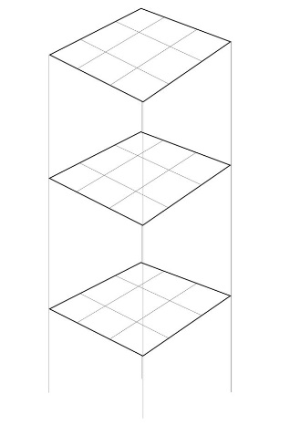*Fig 1 the board players will be playing on*

Once the board has been drawn the players will then play rock paper scissors to decide who goes first and second. After each player has had there turn, they will then do rock paper scissors again and repeat this process until one of the players wins.

3.4 Play testing

This week I enforced much more strict time restraints to ensure that we would be able to do external play testing. We were able to do external play testing with James Wilson and Muhammed Zulfiqar. Both of whom gave our game very positive reviews after playing multiple games with us. They believed that the game play can be very fast in some of the games however this is what we wanted as it stopped the game from dragging on for too long and also reduced the chance of the games ending in a tie, which none of the games that we played did ‘the games either ended with a clear winner. Some of the games which we played in testing are below. (Figure 2A and B)

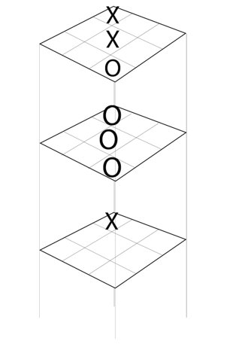(*Figure 2 [A] shows the end result of the game played with Muhammed*)

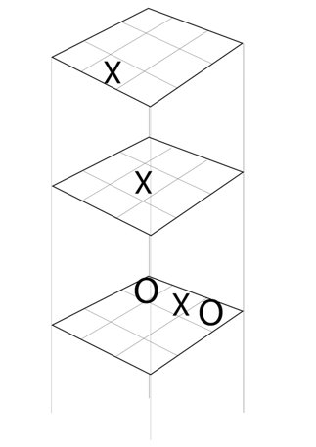(*Figure 2 [B] shows the end result of the game played with James*)